NOTES:
- Stdev seems to be calculated differently in STATA
- STATA has nice summarize detail function that gives percentiles
- Did not add Hispanic count for question 5
- Use same axis if putting plots side-by-side (age histograms by study)
- In the crosses (hair length and color) it’s important to track that one individual is a male and the other is a female
  - Combination space
  - How to do combinations with python
- Know how to apply binomial distribution, must apply to the problem
- Watch answers that ask for mean of people, don’t have fractions of people
- Calculate upper bound: add the .5 with the .9 = .95, then calculate z score for .95
  - Calculate the z score for .5 normally
- EXAM:
  - Working thru formulas by hand, no calculator
  - Describe when binomial distribution can be applied

Part A Insert your answers below and save as a Word document. Show your work. Save the STATA output as an rtf file to be able to include in this document.

- (1) Calculate the mean and standard deviation for the data below.
Mean: 22.818
Standard Deviation: 11.949 (12.2)

(2) Construct a stem and leaf plot and comment on the shape of the plot.
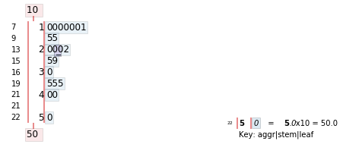
10 50 35 20 11 10 10 20 40 15 20 35 10 22 10 40 10 35 25 30 29 15

2. The Excel file RTOG2trials contains patient characteristics of two RTOG randomized trials (study numbers 9003 and 9501) on testing new therapies for advanced head and neck cancer patients. Bring the data into STATA and perform the following analyses:

- For the variables listed below specify if categorical, discrete, or continuous
- sn = RTOG study number, categorical
- cn = case number, discrete
- age = age in years, continuous
- gender = gender, categorical
- race = race, categorical
- Generate summary statistics (mean, std, min, max) on the variable age for all patients
count 566.000000
mean 58.826855
std 10.002215
min 30.000000
25% 52.000000
50% 59.000000
75% 66.000000
max 90.000000

- Generate summary statistics (mean, std, min, max) on the variable age by study
 | count | mean | std | min | 25% | 50% | 75% | max
sn
9003 | 424.0 | 59.945755 | 9.841985 | 30.0 | 53.75 | 60.0 | 67.0 | 90.0
9501 | 142.0 | 55.485915 | 9.761508 | 31.0 | 49.00 | 55.0 | 63.0 | 79.0

- Find the 25th 50th and 75th percentiles for age (i.e. find Q_{1,} Q_{2,} Q₃) and calculate IQR

25th percentile for Age (Q1): 52.0
50th percentile for Age (Q2): 59.0
75th percentile for Age (Q3): 66.0
IQR: 14.0

- Which study has the highest percentage of Native Americans? How about Hispanics? (Hint: create a frequency table for race by study number)

Study 9501 has the higher percent of Native Americans
Higher percentage of Hispanics on 9003

sn race
9003 white 72.877358
black 20.047170
hispanic 5.188679
oriental 0.943396
other 0.707547
native_american 0.235849
9501 white 71.126761
black 23.239437
hispanic 4.225352
native_american 0.704225
oriental 0.704225
Name: race, dtype: float64

- Generate a Boxplot of age by study (represented in one figure)

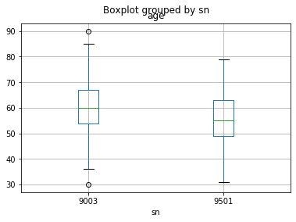

- Generate a histogram of age for all patients, and then histograms of age by study

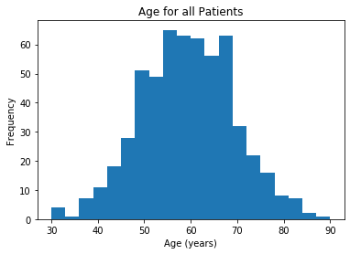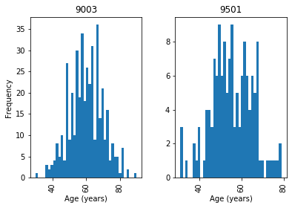

- Describe the age distributions in these two studies based on the summary statistics and graphics

Study 9003 can be described as a normal distribution with a mean of 60 years of age and a standard deviation of 9.8. Study 9501 may be described as a bimodal distribution, suggestion that two groups are present, with a mean of 55.5 years of age and a standard deviation of 9.8.

Variable in database Description Codes
Sn | RTOG study number (=9003 or 9501)
Cn | Case number
Age | Age, in years
gender | Gender | 1= male
 |  | 2= female
Race | Race | 1= white
 |  | 2= hispanic
 |  | 3= black
 |  | 4= oriental
 |  | 6= native American
 |  | 7= other

Reading Assignment

• Chapters 6.1, 6.2, 7.1, 7.2 and 7.4 in the textbook

Part B:

Complete the following problems using the methods we learned in class.

1. A tetrapeptide (a compound consisting of 4 amino acids linked in a chain) has the following amino acid composition: alanine (A), glutamic acid (G), lysine (L), and histidine (H). For example, ALGH and LGHA are two possible chains that can be constructed from these amino acids.

- Draw a tree diagram to represent the 24 ways in which these amino acids can form a tetrapeptide.

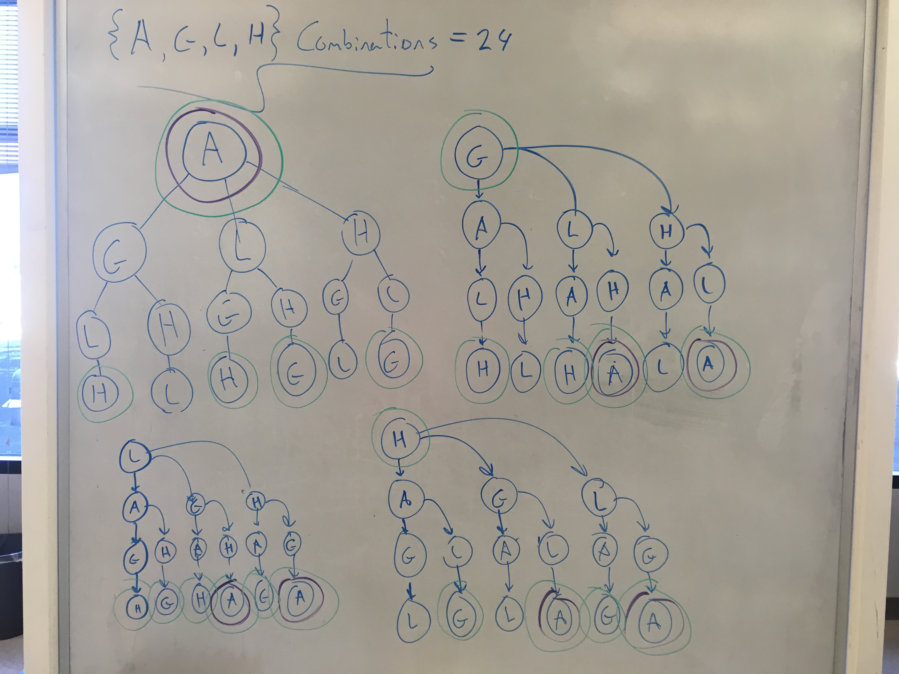

- If each chain is equally likely, what is the probability of finding A at either end of the chain?
(6+2+2+2)/24 = 12/24 = .5

- What is the probability that lysine is not found at either end of the chain?

(4+4+0+4)/24 = 12/24 = .5

2. In guinea pigs, long hair (L) is dominant to short hair (l), and black fur (B) is dominant to albino fur (b). Answer the following questions.

(a) What are the possible genotypes of the offspring of a black haired parent and an albino, and the probability of each genotype?

If considering the fur color alleles (Bb) alone:
- Bb (Black fur): 6/8 = .75
- bb (albino fur): 2/8 = .25
If considering both fur color (Bb) and hair length (Ll) alleles:
- BbLL: .1875
- BbLl: .375
- Bbll: .1875
- bbLL: .0625
- bbLl: .125
- bbll: .0625

(b) If two longhaired parents are mated, what is the probability of a short-haired offspring?

1/16 = .0625

3. Toxicity monitoring is very important for patients receiving cancer treatment and mandatory in clinical trials. For example, breast cancer patients receiving HER2 targeted therapy may have a 10% probability to have cardiac toxicity. Such toxicity is closely monitored. A study will enroll 30 patients with such conditions.

- Why is this a suitable problem to apply the binomial distribution theory?

This problem is suitable for the application of the binomial distribution theory because the process here (patients are being provided cancer treatment) is being recorded a specific number of times (n = 30 patients) and the outcome for a given event has just two levels, either success (cardiac toxicity) or failure (no cardiac toxicity). Each event yields a success with a probability of P. Patients have two outcomes, independent trials taking place.

- What is the probability of observing one patient with a cardiac event among the 30 patients?

0.1413

- What is the probability that at least one patients having cardiac events among the 30?

0.9576

- What is the probability that at least two patients having cardiac events among the 30?

0.8163

4. Pagano, page 193 #12:

According to the Behavioral Risk Factor Surveillance System, 58% of all Americans adhere to a sedentary lifestyle.

- If you selected repeated samples of size twelve from the U.S. population, what would be the mean number of individuals per sample who do not exercise regularly? What would be the standard deviation?
Mean: 6.96
StDev: 1.71
- Suppose that you select a sample of twelve individuals and find that ten of them do not exercise regularly. Assuming that the Surveillance System is correct, what is the probability that you would have obtained results as bad as or worse than those you observed?
0.0642
- Also explain why the binomial distribution is suitable here.
Incorporating a binomial distribution here is suitable because the process of assessing the exercise activity of each patient (process) is beign recorded over a specific number of patients (n=12) with an outcome of just two levels, non-regular exercise (success) and exercise regularly (failure).

There are a fixed number of trials, the outcome is binary (sedentary lifestyle or not), trials are independent, outcome is one person does not affect another

5. Pagano, page 194 #18:

Among females in the United States between 18 and 74 years of age, diastolic blood pressure is normally distributed with mean µ = 77 mm Hg and standard deviation σ = 11.6 mm Hg.

- What is the probability that a randomly selected woman has a diastolic blood pressure less than 60 mm Hg?
0.0714
- What is the probability that she has a diastolic blood pressure greater than 90 mm Hg?
0.01312 (should be .1312)
- What is the probability that she has a diastolic blood pressure between 60 and 90 mm Hg?
0.7974

- Find the upper and lower bounds of diastolic blood pressure between which 90% of the women find their diastolic blood pressure values.
Lower bound: 57.92
Upper bound: 96.08
Shown Work:

